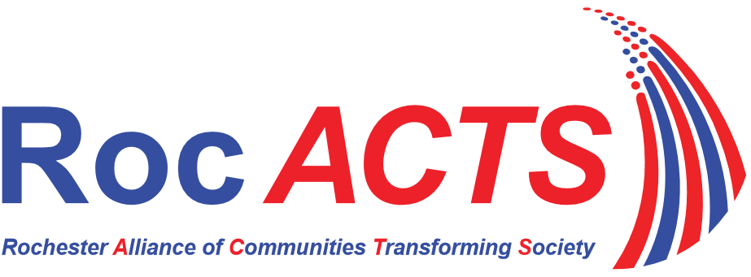
“Transforming our community together toward equity and justice through community organizing”

Membership Application

Membership will be open to any individual, faith community or non-profit organization in the Greater Rochester metropolitan area that supports and endorses the vision and mission of RocACTS, agrees to follow its Bylaws and is approved by the Board.

Our Vision - An empowered and engaged community, grounded in shared values, working to build and sustain an equitable, just and moral society.

Recommended Annual Dues Structure
(Please Check appropriate box)

Individual Membership | Congregation/Organization Membership
 | Number of Members | Membership Dues
☐ Regular $30 | ☐ <100 | $100
☐ Low Income $12 | ☐ 100-250 | $250
 | ☐ 251-500 | $500
 | ☐ 501-1,000 | $1,000
 | ☐ 1,000+ | $1,500

Individual or Organization/Congregation Name: |  |  |  |  |  | Click here to enter text.
Address: |  | Click here to enter text.
Phone: Office |  |  |  | Click here to enter text. |  |  | Mobile | Click here to enter text.
E-Mail: | Click here to enter text.
For Organization/Congregations Members:
Faith Leader/Director Name: |  |  |  |  | Click here to enter text.
Signature: |  |  | Click here to enter text.

Return this application with your dues to: 121 Fitzhugh St. N., Rochester, NY 14614.
Congregation/Organization Member dues can be made in 2 installments.
Individual Member Dues must be paid in full at time of application.
Make checks payable to RocACTS.

